RGB Lamp

Schematic description
This is a very simple design for a WiFi RGB lamp using an LED strip, based on the ESP32-C3 Super Mini module and the WLED project.

Construction
The assembly features components mounted on one side of the PCB. The ESP32-C3 module is attached to the board using pin headers. The only challenging component is resistor R1, which comes in a 1206 SMD package. The wires for the LED strip are connected to the opposite side of the PCB; a pin header can be used here as well to facilitate the connection.
Caution: Observe the correct power supply polarity when connecting the LED strip. Reversing the polarity could destroy it.

How to get it into service
First, you need to flash the WLED firmware onto the module. The easiest way is to use the web interface at https://install.wled.me/. Use the Chrome browser, as it works well with the serial interface.
Procedure:
- Connect the module to your PC using a USB cable.
- Hold down the BOOT button on the module and briefly press the RESET button (you must keep holding BOOT while pressing RESET)
- Release the BOOT button.
- Leave the default settings on the webpage and click Install.
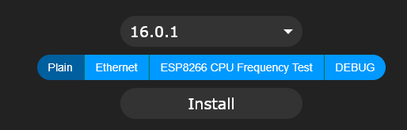
- Select the module's serial port and click the Connect button

- Select Install WLED
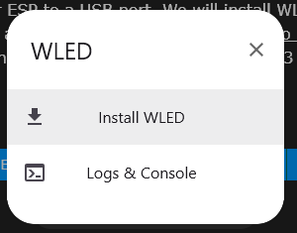
- Check Erase device and then click next. Confirm the installation by clicking Install.
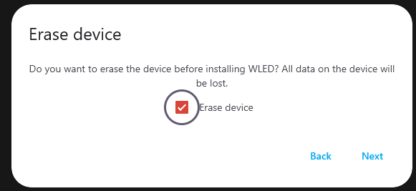
- Installation typically takes only a few seconds
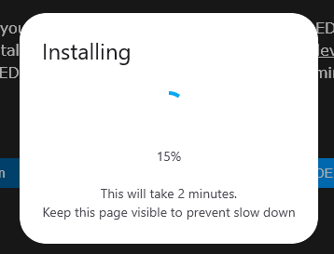
- Disconnect and connect the module to USB
- Now you need to configure the module's connection to your Wi-Fi network. The module is currently in access point mode, and you need to connect to it. Search for the "WLED-AP" network on your computer or phone and connect to it.
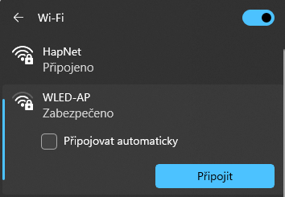
- The initial settings page should open automatically. Click on WIFI SETTINGS.
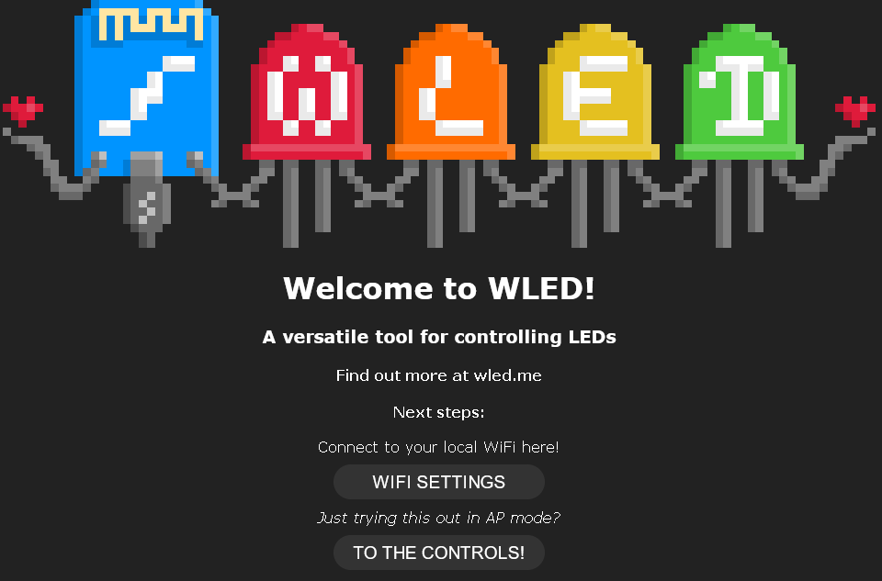
- Enter the name of your local Wi-Fi network and the password. Then click Save & Connect.
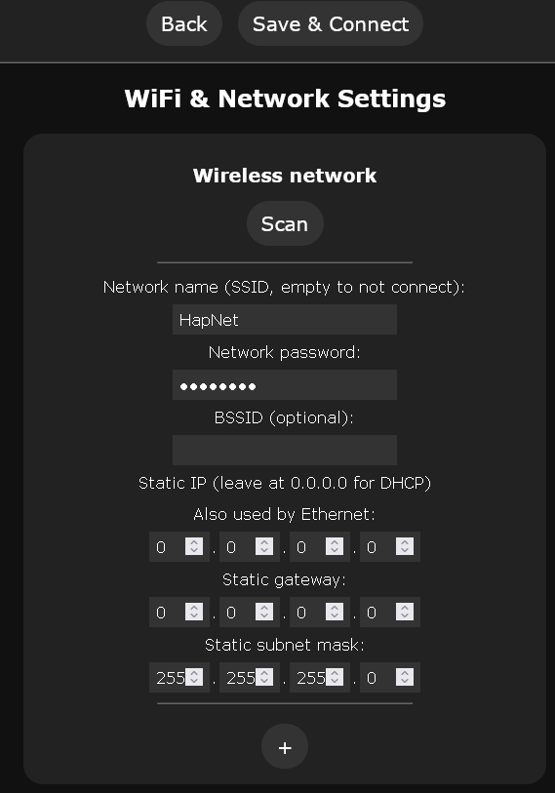
- The module will now restart and should connect to the local network.
- Install the WLED app on your mobile phone from Google Play.
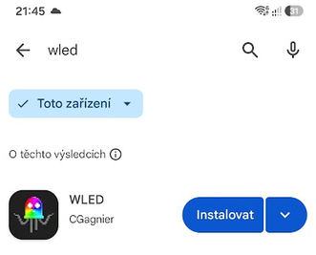
- After opening the app, your module should be visible. Everything is now set up—you can adjust the brightness of your lamp.
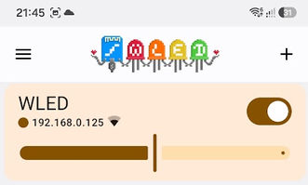
- The circuit is wired to work with the default settings – the LEDs should light up. The button is connected to GPIO5 and must be configured in the Config tab.
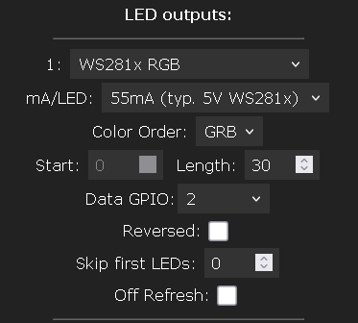
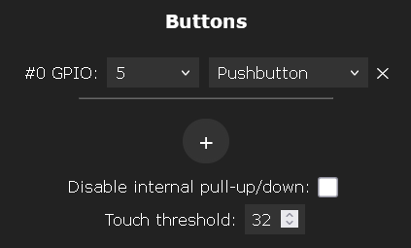

Bill of materials
Annotation | Value | Qty
R1 | 10k, 1206 | 1
U1 | ESP32-C3 super mini | 1
SW1 | Button 6x6mm, 90° | 1
J1 | Connection to the LED strip
 | Pin header for U1, 2.54mm, 8 pin | 2
 | RGB LED strip WS2812B, 50cm, 60 LED/m | 50cm
 | Screw 2.2x6.5mm (Bossard 1376012) | 7

3D print
Standard white PLA filament was used to print the lamp shade. It diffuses light better than transparent filament. For the other parts, choose the filament of your choice.

Mechanical construction
First, adhere the LED strip to the inner tube in a helical pattern, starting from the top edge. If the strip starts to peel off, secure it with super glue.
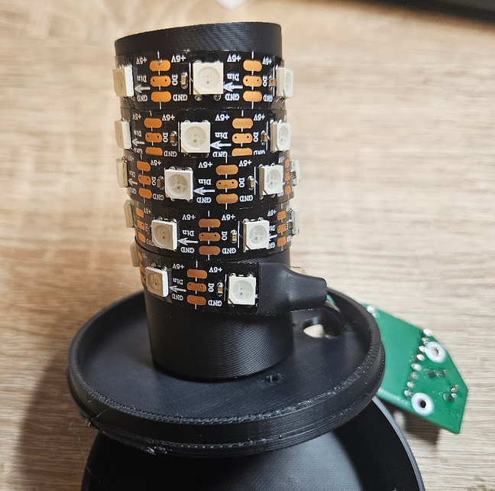
Next, thread the LED strip wires through the center piece and solder them to the printed circuit board. The tube containing the LED strip can be secured with super glue.
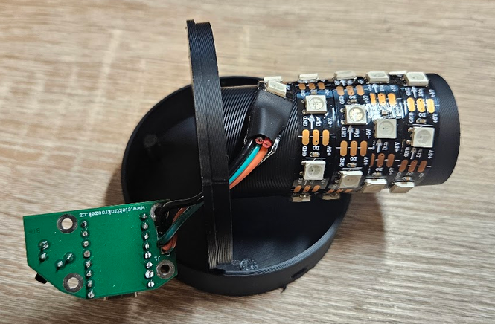
Screw the printed circuit board onto the middle section using the spacer.
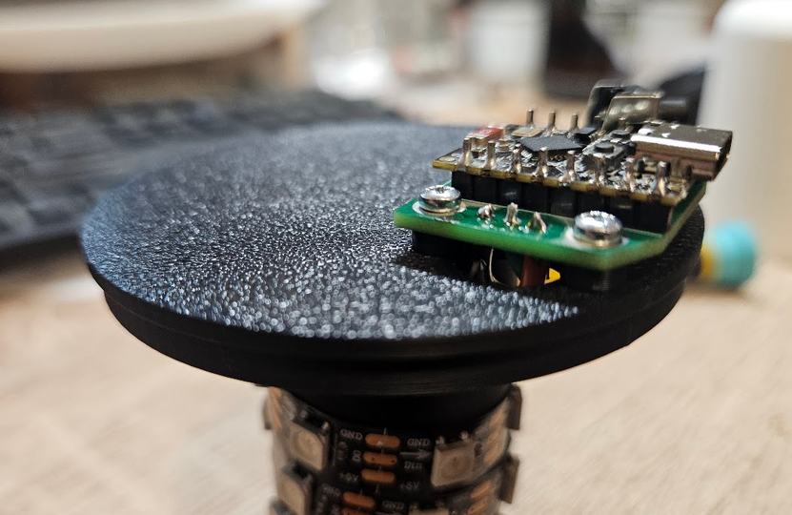
We glue the tactile cap onto the button.
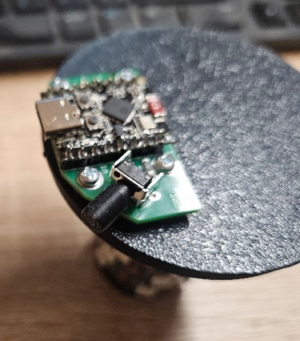
And we insert the entire assembly into the bottom part.
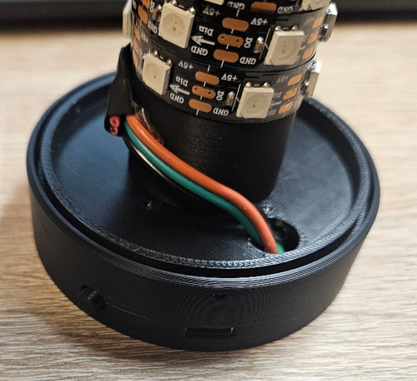
Insert the top cover and secure it with 3 screws.
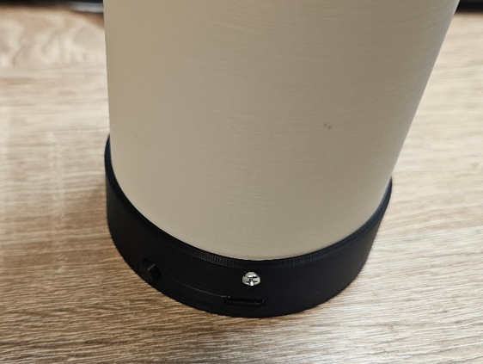

PCB assembly
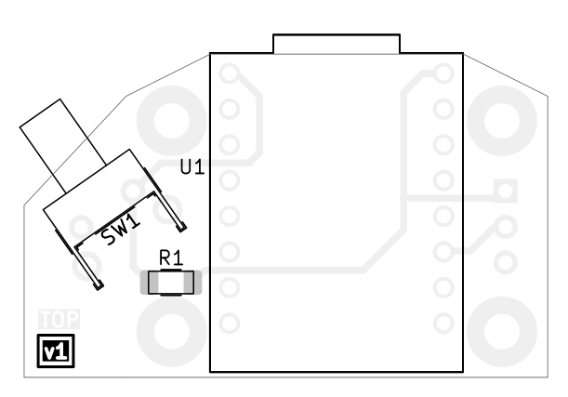
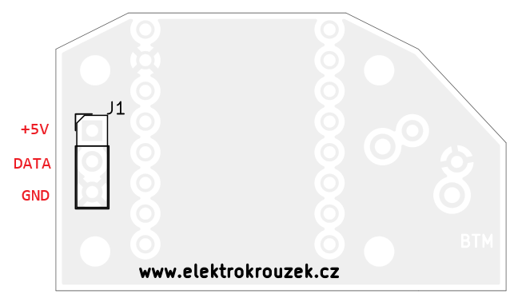

Schematic
